[19]
Explainable AI

Explainable AI

https://www.codecademy.com/ext-courses/explainable-ai

Explainable AI
The inner workings of many deep learning systems are complicated, if not impossible, for the human mind to comprehend. Explainable Artificial Intelligence (XAI) aims to provide AI experts with transparency into these systems.
In this course, you'll describe what Explainable AI is, how to use it, and the data structures behind XAI's preferred algorithms. Next, you'll explore the interpretability problem and today's state-of-the-art solutions to it. You'll identify XAI regulations, define the "right to explanation", and illustrate real-world examples where this has been applicable.
You'll move on to recognize both the Counterfactual and Axiomatic methods, distinguishing their pros and cons. You'll investigate the intelligible models method, along with the concepts of monotonicity and rationalization. Finally, you'll learn how to use a Generative Adversarial Network.

Table of Contents
1. Video: Course Overview (it_aiexpldj_01_enus_01)
2. Video: Explainable AI (it_aiexpldj_01_enus_02)
3. Video: The Interpretability Problem (it_aiexpldj_01_enus_03)
4. Video: Right to Explanation (it_aiexpldj_01_enus_04)
5. Video: Counterfactual Method (it_aiexpldj_01_enus_05)
6. Video: Axiomatic Attribution (it_aiexpldj_01_enus_06)
7. Video: Intelligible Models (it_aiexpldj_01_enus_07)
8. Video: Monotonicity (it_aiexpldj_01_enus_08)
9. Video: Rationalization (it_aiexpldj_01_enus_09)
10. Video: Feature Visualization (it_aiexpldj_01_enus_10)
11. Video: Course Summary (it_aiexpldj_01_enus_11)

1. Video: Course Overview (it_aiexpldj_01_enus_01)

In this video, discover the key concepts covered in this course.
- discover the key concepts covered in this course
[Video description begins] Topic title: Course Overview [Video description ends]
Hi, my name is Joaquin Marques. And I am a Principal AI architect and Data Scientist at Kanayma LLC, a boutique AI firm specializing in predictive analytics and deep learning.
[Video description begins] Your host for this session is Joaquin Marques. He is a Principal Data Scientist. [Video description ends]
I have been working on artificial intelligence since the early 1980s, and worked for many years at several of the great centers of research and development of AI, natural language processing, NLP and machine learning. At CompuTeach and Cognitive Systems, two spinoffs of Yale's Department of Artificial Intelligence, at Bell Labs now Verizon, at IBM TJ Watson labs. And currently, as an AI Consultant at Experfy, a spinoff of the Harvard Incubation Lab. While at IBM, I was awarded three US patents in natural language processing and understanding. In this video, I will explain the fundamental concepts behind explainable AI, the differences between inherently explainable AI and inherently opaque AI, and provide examples of both.
The concept of black box as it applies to explainable AI and deep learning and the goal of converting the black box into a transparent or glass box. We will explain what the interpretability problem is and what are Google's principles of interpretability. We will look at practical examples that shed light on those principles. We will discuss the three main approaches to interpretability and provide examples of each. Next, we will explain the legal and social concept of right to explanation and give three examples of how it is being applied around the world. Finally, we will dig deep into each one of six different contemporary approaches to AI explainability and how to think of them when applied to the same problem. So let's get started.

2. Video: Explainable AI (it_aiexpldj_01_enus_02)
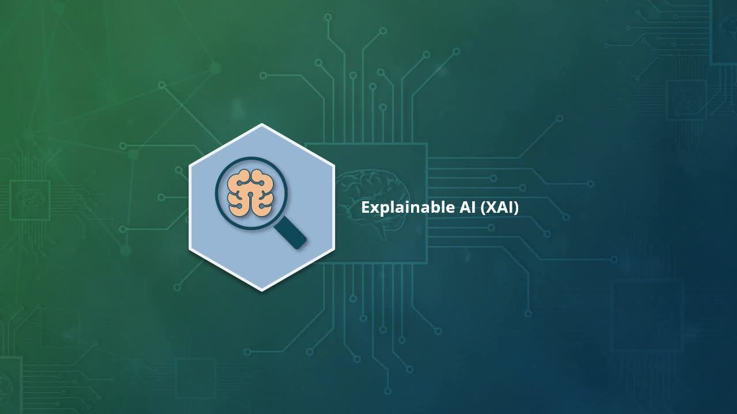
Learn how to recognize what Explainable AI is and why it is important.
- recognize what Explainable AI is and its significance
[Video description begins] Topic title: Explainable AI. Your host for this session is Joaquin Marques. [Video description ends]
What is explainable AI? Explainable AI, or XAI, is a set of techniques and methods used in deep learning systems to extract the information needed to explain how those systems work, in such a way that it can be readily understood by human experts. That a discipline such as explainable AI exists at all is evidence that the inner workings of many current deep learning systems are very hard or even impossible for us humans to understand. That is why those systems are treated as black boxes, and why the goal of explainable AI is to make those black boxes more transparent.
The easiest way to avoid having to explain the inner workings of an AI application is to use algorithms that are inherently explainable, i.e., easy for humans to understand. And to avoid using those algorithms that are inherently opaque, that is hard or impossible for humans to understand. So why not use exclusively inherently explainable algorithms and do away with the problem altogether? We would wish it were that simple. But it turns out that there are problems for which the best known solution is an opaque algorithm. No explainable algorithm will do as good a job. First, let's look at some examples of inherently explainable algorithms, such as decision trees, regression algorithms, Bayesian classifiers, and support vector machines. The inner workings of each one of these algorithms can be easily understood by human experts
just by looking at a description of their data structures and the operations on those structures contained in their code implementations. A curious AI architect that has the time, the drive, and the patience can really understand it all after putting some effort. But how are inherently opaque algorithms different? They are different because they are much more complex, both in the structure of their models and in their inner workings. For example, a decision tree can be very large and involve many different variables and branches. But behind each node in the tree, there is a simple decision based on the comparison between two or more variables. Once you understand that, you understand the whole tree. But when we are talking about a deep learning neural network, the complexity grows exponentially. As a neural network gets strained, its interconnections get stronger or weaker, with the weakest getting pruned out altogether.
The resulting structure and its functionality are very hard to understand. There are no simple rules that allow us to navigate it. Genetic algorithms are even more opaque because they are not based on deterministic processes but random ones. They work based on the principles of code recombination and mutation. Because most AI architects are going to be working with deep learning systems and not genetic ones, we are going to leave genetic algorithms out of this course. Let's get back to the concept of the black box. We say that a deep learning algorithm or model is a black box because we do not really understand how it reaches its decisions. Explainable AI's main goal is to make their internal decision making transparent. That's transforming the black box into a glass box that you can peer into and see how the machinery works inside. Before we get to the methods and techniques that make the black box into a glass box, let us address another important concept.

3. Video: The Interpretability Problem (it_aiexpldj_01_enus_03)
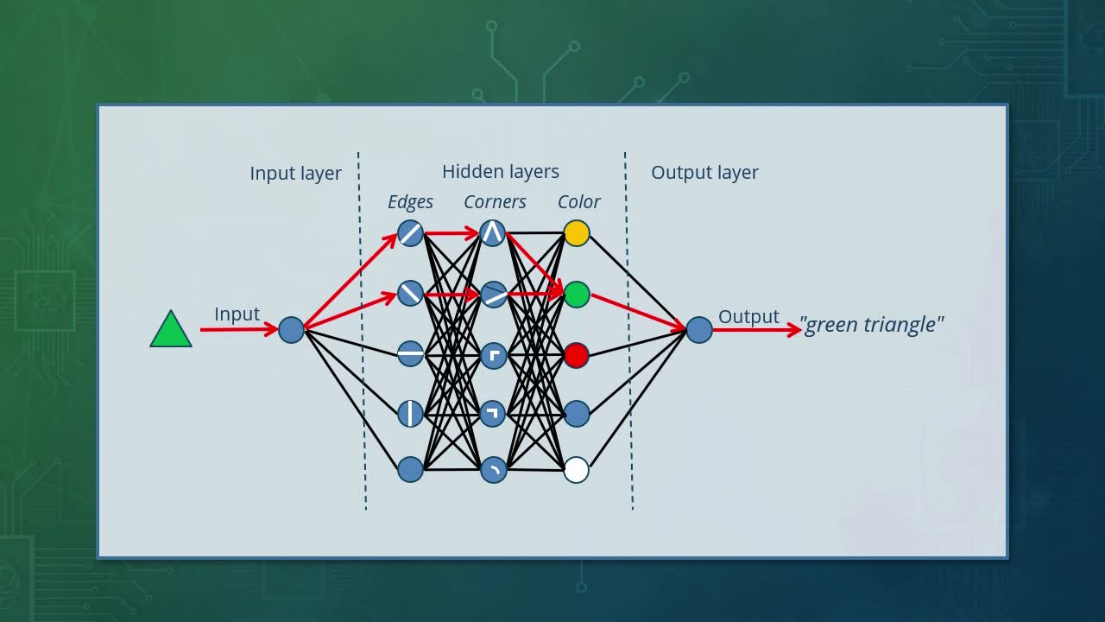
In this video, you will learn how to define the Interpretability Problem and why it is important.
- define the Interpretability Problem and its importance
[Video description begins] Topic title: The Interpretability Problem. Your host for this session is Joaquin Marques. [Video description ends]
How exactly do we interpret or explain the inner workings of a deep learning system? This question represents the embodiment of the interpretability problem. In the early days of neural networks, the answer to the interpretability problem remained a mystery. But nowadays we can provide much better glimpses of the answer. But first, let's try to understand how a neural network works by using a simple example. Suppose we wanted to create a neural network that was capable of distinguishing simple geometric shapes and their colors. It needs to recognize triangles, squares, and circles in five different colors.
Green, yellow, red, blue, and white. How would we structure such a network? The one you'll see on the video is an example. The network consists of three main layers, the input layer, the hidden layer, and the output layer. Both the input layer and the output layer contain a single node each known as input and output. The interesting part is the hidden layers.
In our case, there are three of them. The first one from the left and the closest to the input layer represents the different types of edges in the input figure. The nodes in the edges layer get activated whenever the input figure presents a specific type of edge. For example, the triangle has slanted edges, so it activates the top two nodes in the edges layer. The middle layer in the hidden layers group activates when it sees a specific type of corner. So we label the corners layer.
In the case of the triangle, its corners look like acute angles. In the top two nodes in the corners layer match the corners of the triangle, so they get activated. The rightmost hidden layer recognizes different colors. So it is called the colored layer. In our case, the triangle is green. So the green node in the color layer is activated. The expected output should be labeled, green triangle. The red arrows show the activation path, or which nodes get activated in each layer from the input to the output layers. Of course, the hidden layers in a real neural network are not structured as simply as the ones in our example. Often a layer checks for combinations of multiple attributes of the input simultaneously, not just one attribute.
But this simple example allows you to get the idea. Here's another example with the same neural network, but this time using a yellow square as input. You can clearly see that a different set of nodes and activation paths are involved in each of the hidden layers. Finally, let's look at what happens when we use a red circle as input. The circle has no edges, round corners, and a new color, red. Therefore, an entirely different set of nodes gets activated this time with a different set of activation paths. We know that a deep learning system is a neural network with many hidden layers. When we train a deep learning network, the knowledge implicit in the training data is reflected in the changes to the inner structure of its hidden layers.
So we need to understand the structure of the hidden layers to understand how that knowledge is stored, including what each layer contributes to that knowledge. In short, we need to understand its computational graph. Now we also need to understand what happens when a set of nodes in the hidden layers gets triggered by a particular input or similar inputs. And how those nodes are interconnected. The sets that get activated for the green triangle, yellow square, and red circle are all different and separate. Finally in our example neural network, are there commonalities between the nodes that get activated for let's say, all the triangles, or squares, or circles?
If there are, maybe those common nodes represent the concept of a triangle, a square, or a circle. Let's try and find out. From our example neural network, it should be obvious that the knowledge required to classify geometric objects of different colors is embedded in its hidden layers. Knowledge about the different types of edges, corners, and colors is divided into three different specialized hidden layers. Each input first triggers the edges layer, which in turn triggers the corners layer, which in turn triggers the color layer. And the colored layer triggers the output layer, and we get the result in the output node. The whole structure and how it is connected and activated is called the computational graph.
Remember tensor flow? It is designed for programming static computational graphs. And do you remember PyTorch? That one is designed for programming dynamic computational graphs. Both are ideal to model neural networks. To understand how a deep learning model reaches its decisions, it is necessary to understand how a whole group of neurons act together to produce a decision. Different inputs activate different groups of neurons or activation paths to reach different outputs or decisions. The video shows what nodes in the hidden layers get activated when the input is a yellow square.
And we showed you before how different shapes and different colors trigger different sets of interconnected nodes or activation paths across the three hidden layers. We also need to understand how deep learning networks represent individual concepts internally. And how these concepts are combined to produce a conceptual output. The video shows inside the blue rectangle with rounded corners, the four nodes that are activated every time the network sees a triangle in its input. We say that those four nodes embed the concept of a triangle, that together they represent that concept. The video also shows inside the yellow rectangle with rounded corners, the four nodes are activated every time the network sees a rectangle figure in its input. They represent the concept of a square or that of a rectangle. And the two nodes at the bottom inside the green rectangle with rounded corners, activate for circles and circles only.
They stand for the concept of a circle. Notice that the colored concept rectangles or areas with rounded corners do not overlap in our case. This is because we are only showing a simple example. But in more complex networks, those concept areas may very well overlap when for example an input matches two or more concepts at once. This would be the case if we need the neural network to recognize an object that it's a combination of a circle and a triangle, or with two different colors, for example.
Looking at a deep learning system as a black box that we need to study in order to understand what's going on inside, there are three main approaches that we can follow. Constraint, perturbation, and Generative Adversarial Networks or GANS. You will find examples of these approach in the intelligible models, monotonicity, and rationalization models further ahead in this course. The perturbation approach consists of perturbing or modifying the inputs to a train deep learning model while monitoring its outputs to probe its decision making boundaries.
In this approach, we are constantly asking the question, how does it transition from one type of decision to another? The counterfactual and axiomatic attribution methods presented further ahead in this course are examples of this kind of approach. Finally, with the generative adversarial networks or GANS approach, we add a second neural network that has been trained to generate the kind of input that a train deep learning model expects. And uses the first network to feed new input into the second network, while probing the latter for knowledge gaps. The first network, the one that generates the right kind of input, contribute the generative part. While the second network plays the adversarial role. A good example of a gain is feature visualization. We are going to learn more details about examples of each type of approach to interpretability later in this course.

4. Video: Right to Explanation (it_aiexpldj_01_enus_04)
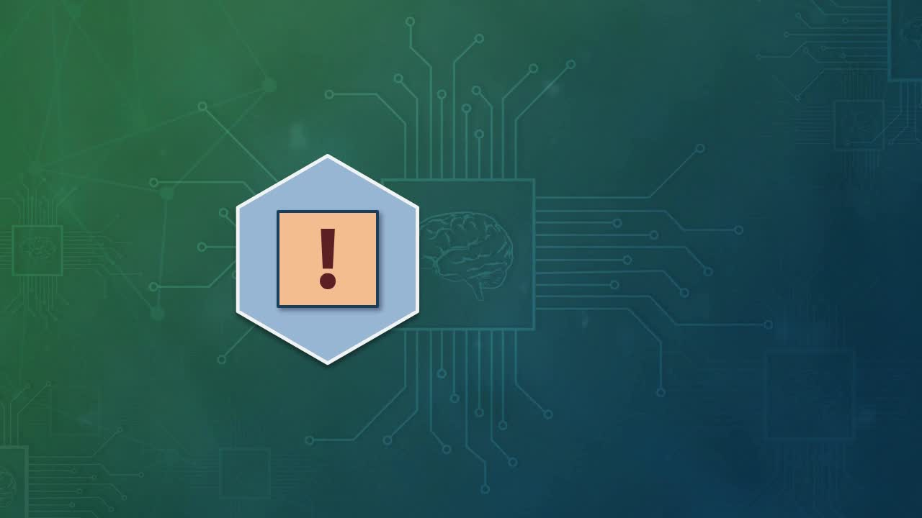
Find out how to define 'right to explanation' regulations and identify real-world use cases.
- define 'right to explanation' regulations and identify real-world use cases
[Video description begins] Topic title: Right to Explanation. Your host for this session is Joaquin Marques. [Video description ends]
Explainable AI is a very complex subject that needs to be approached from many perspectives. Due to its importance and potential consequences, the perspectives of the legal and social sciences are very important. From a legal point of view, algorithms need to be regulated to guarantee that the results are kept within acceptable social, ethical, and legal standards. Such regulations are based on the social concept of the right to explanation. Which is the legal right that an individual has to be given a clear and simple explanation of the output of an algorithm. There are a few examples of such laws both in the US and the European Union. Let's look at three specific regulations that contain right to explanation clauses.
The Equal Credit Opportunity Act in the US, the General Data Protection Regulation in the EU, and Digital Republic Act in France. The Equal Credit Opportunity Act in the US, regulates adverse credit score decisions by forcing creditors to provide applicants with clear reasons why their credit applications were denied. It is not enough for creditors to invoke their own hidden internal policies. Applicants have a right to an explanation of the reasons behind their rejection.
The EU's General Data Protection Regulation or GDPR, says that the data subject has the right to an explanation of the reasons behind legal or financial decisions made by automated systems impacting the data subject. For instance, Digital Republic Act gives an individual a right to a clear explanation of the details behind any legal or administrative decision made by public sector organizations that impact that individual, even if the decision making process is not fully automated. Expect to see right to explanation regulations from many other countries very soon.

5. Video: Counterfactual Method (it_aiexpldj_01_enus_05)
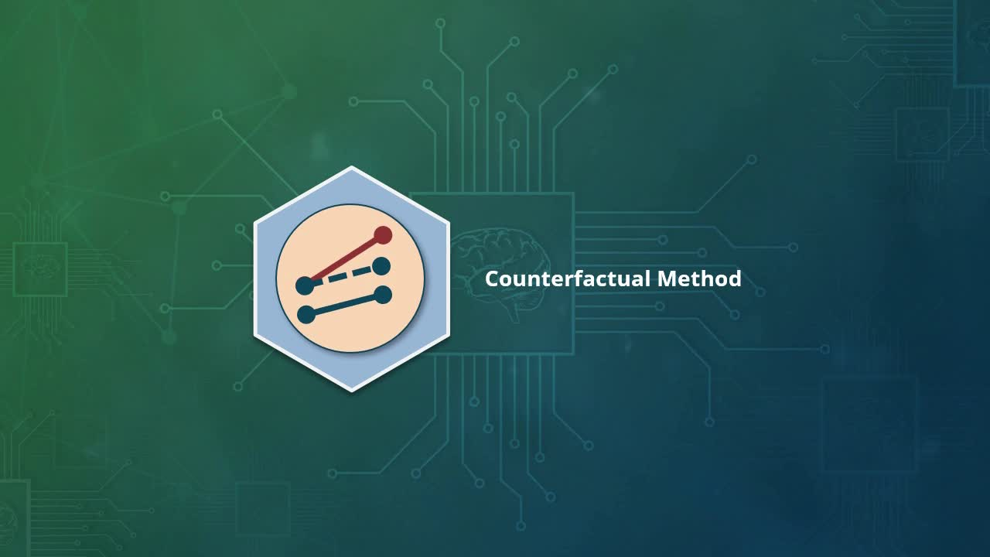
In this video, you will learn how to identify the meaning and application of the counterfactual method.
- identify the meaning and application of the counterfactual method
[Video description begins] Topic title: Counterfactual Method. Your host for this session is Joaquin Marques. [Video description ends]
The counterfactual method is our first interpretability method. And it is based on the use of counterfactuals to test the boundaries of a neural net's decision. Counterfactuals are examples of an actual situation that contains one or more key variations of the original. They do not correspond to real, actual situations, but rather to make believe ones. They run counter to the facts, to reality. And that's why they are called counterfactuals. They usually respond to questions of the type, what if such and such a thing were true or not true? How would the AI system respond to such hypothetical situations or inputs? Let's look at an example of the counterfactual method. Suppose we have trained a neural network to recognize the famous Mona Lisa painting by Leonardo da Vinci.
We have trained it and optimized it so well that every time it is presented with a painting that is not the original Mona Lisa, it rejects it as a fake. But if it is the real Mona Lisa it will declare it as real, unless we allow our neural network to be seriously over fitted during training. It should allow some variations from the original and still classify them as the real Mona Lisa. So there is room for some variation here. Now the key question becomes, what type of variation will the network accept as real Mona Lisas? To answer this question, we present the neural network with many variations on the original Mona Lisa painting. On the video, we show you five such variations. One where she's making the peace sign, one where she's wearing an eye patch. One with her hair up, one with eyelashes, and one where she's sad. These are all counterfactuals to the real Mona Lisa.
As we present them to the network, we keep track of its responses. We may notice for example, that the one with eyelashes is immediately rejected as being a fake. So now we know that the network does not like eyelashes on the Mona Lisa. It also rejects the one with the eye patch. So now we know that any variation in the eyes is a cause for rejection. But suppose it accepts as real the Mona Lisa with her hair up. We can then conclude the neural net is not paying much attention to hair style. This way, as we present more and more counterfactuals to the network, we learn more and more about how the network makes its decisions about the real Mona Lisa. This approach to explainable AI is quite interesting. But it takes a lot of input counterfactuals and a lot of testing to obtain a clear picture of the inner workings of the network's blackbox.

6. Video: Axiomatic Attribution (it_aiexpldj_01_enus_06)
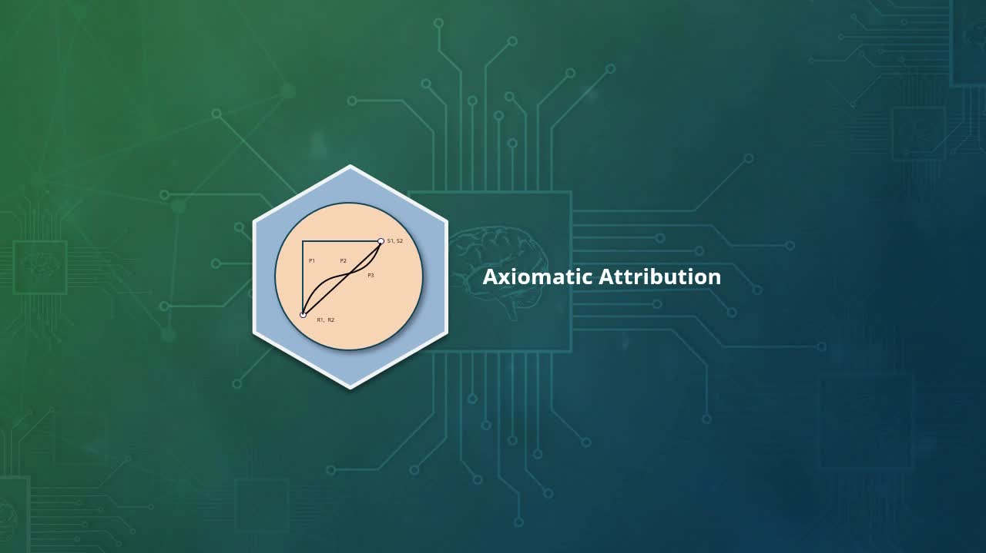
During this video, you will learn how to identify the meaning and apply axiomatic attribution.
- identify the meaning and application of axiomatic attribution
[Video description begins] Topic title: Axiomatic Attribution. Your host for this session is Joaquin Marques. [Video description ends]
The axiomatic attribute method requires a lot less testing than the counterfactual one. It is based on the same idea as the pictionary game. Where players try to guess the object, animal, person, place or event partially sketched on a piece of paper. How do we apply the axiomatic attribute method to the task of recognizing the Mona Lisa. We start by sketching per stroke by stroke, presenting the partial result after each stroke to be scanned and classified by the neural network. At first, the network does not recognize any of the partial sketches as a real Mona Lisa. But as you accumulate strokes, more and more strokes, at some point, it will recognize the sketch as the real thing.
This will tell us what is the minimum amount of information that we need to provide the network for it to recognize the sketch as being the real Mona Lisa. This method, just like the counterfactual method we just saw, is an example of the perturbation approach. We add perturb more and more information with every step to test where the decision boundaries of the neural net black box are. The axiomatic method takes fewer input samples and less testing time than the counterfactual method to reach a sample that passes the real Mona Lisa threshold.

7. Video: Intelligible Models (it_aiexpldj_01_enus_07)

In this video, you will learn how to define the meaning and recognize the purpose of intelligible models.
- define the meaning and recognize the purpose of intelligible models
[Video description begins] Topic title: Intelligible Models. Your host for this session is Joaquin Marques. [Video description ends]
The intelligible models approach is completely different from the other methods we will discuss in this course. For one thing, it does not handle images well. It is based on pure statistic number crunching. So how can we apply it to classify our Mona Lisa? Well, by using a little imagination. If you think about it, every painting ever painted was created using a unique amount of specific paints, on specific areas of a specific canvas. Call it its chemical signature. A dedicated scientist can take microscopic samples from different parts of that canvas. Analyze them using a mass spectrometer, and create a list of chemical compounds used by area.
That list would be unique to that painting. Also, very good fakes would have a very similar though not identical chemical fingerprint. And one can measure their degree of similarity using statistical analysis or more specifically generalized additive model or GAM algorithms. This technique is known as intelligible models. Notice that doing this would require creating real physical Mona Lisa fakes. Which would take a lot of time and much expense. The other methods can get away with producing digital fakes, but the intelligible models method requires real, physical fakes. An equivalent approach would be to x-ray our Mona Lisa to figure out every stroke Da Vinci to paint his masterpiece. Its direction, length, width, the type, and size of the brush.
The twirl of the brush along the strokes path in the exact age and type of paint mixture on the brush. This would also constitute a unique signature or fingerprint that only an identical fake could duplicate. This approach would allow us to create a perfect fake Mona Lisa indistinguishable from the original. We could use this information to program a robot to paint the fake Mona Lisas by varying the stroke instructions slightly every time. Deviating ever so slightly from the original perfect fake Mona Lisa. We could then use GAMs to figure out their degree of similarity to the original painting. And we could have the robot produce as many fakes as needed, to figure out how far one could take those variations before our neural network calls it a fake. This is the heart of the intelligible models approach.

8. Video: Monotonicity (it_aiexpldj_01_enus_08)
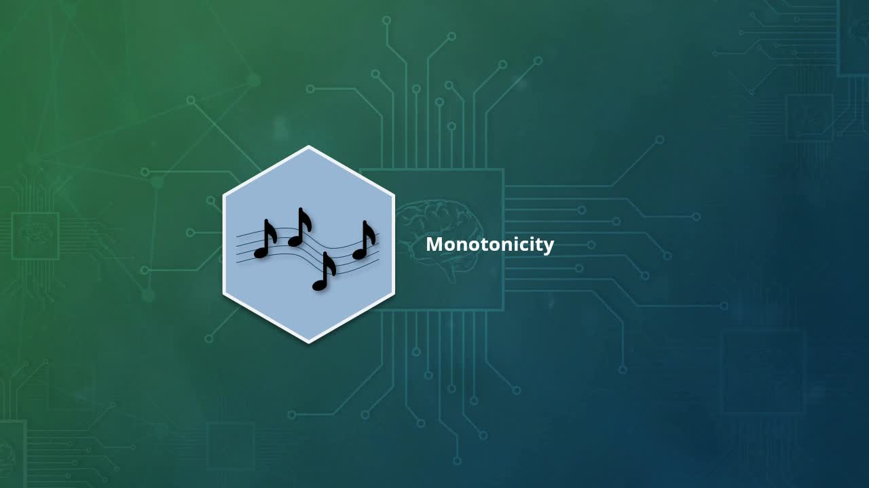
In this video, you will define the meaning of monotonicity and recognize its real-world use.
- define the meaning and recognize the real-world use of monotonicity
[Video description begins] Topic title: Monotonicity. Your host for this session is Joaquin Marques. [Video description ends]
The concept behind the monotonicity approach to interpretability is a very hard one to explain to non-mathematicians. But here is the idea. Every time we apply AI to a problem, what the AI does is to convert the data associated with the problem into numbers. And then compares those numbers with each other and with a set of reference numbers corresponding to our goal, that is, the real Mona Lisa. Sometimes, if the fakes are really good, the differences between those numbers are very tiny and difficult to detect. To handle these problem, algorithms use mathematical functions that enhance those differences to make them stand out. These functions blow the differences up. And for that reason, they tend to be nonlinear functions, such as exponential functions.
But what if instead of concentrating on the differences between the fakes and the original, we want to emphasize their similarities. In that case, we would need to use functions that grow more slowly or remain the same as the differences increase. Such functions are called monotonic or single tone like a repeated tone in a musical score. The values of these monotonic functions tend to remain within a narrow range as the actual differences between the fakes and the original increase and stay within that range, until those differences become too large to ignore. Now that you understand the idea of monotonicity, how can we apply it to our Mona Lisa recognition problem? Monotonicity focuses on monotonic features of the image, such as the mysterious smile, the crossed hands, the eyes, the horizontal line behind the Mona Lisa.
These features tend to remain the same across all the fakes because those are the features that allow a painting to be recognized as a Mona Lisa. Therefore, the functions that model the differences between those features in the original, and the same features in the fakes need to be monotonic to preserve their similarities and allow for distortions of the original Mona Lisa without jumping the gun too soon and call them a fake. Imagine for a moment that Picasso and Botero had decided to reinterpret the Mona Lisa in their own unique styles. The results would still be identifiable as Mona Lisa's, even though they could not be confused with the original one. They would also be identifiable as a Picasso or a Botero. But still anybody would be able to say looking at the paintings, these are versions of the Mona Lisa, not copies of the original one.
A neural network that exhibits monotonicity can identify pictures that follow a Mona Lisa theme even if they are not Mona Lisas, even abstract paintings of the Mona Lisa, just like we humans. All other interpretability models we discuss in this video, concentrate on detecting tiny differences. Their associated neural networks acts as critics. Even harsh critics, and their decisions can be described as adversarial attacks. They are adversaries that subject their input to criticism or attack, but monotonicity acts very differently. A neural network that exhibits monotonicity will continue to hold that the fakes are like the original, until their differences grow beyond recognition. It is a very robust method resistant to adversarial attacks. Its recognition boundaries are very broad compared to those of other methods. Keep in mind that any given neural network can exhibit both a degree of monotonicity and another degree of adversarial behavior at once.

9. Video: Rationalization (it_aiexpldj_01_enus_09)
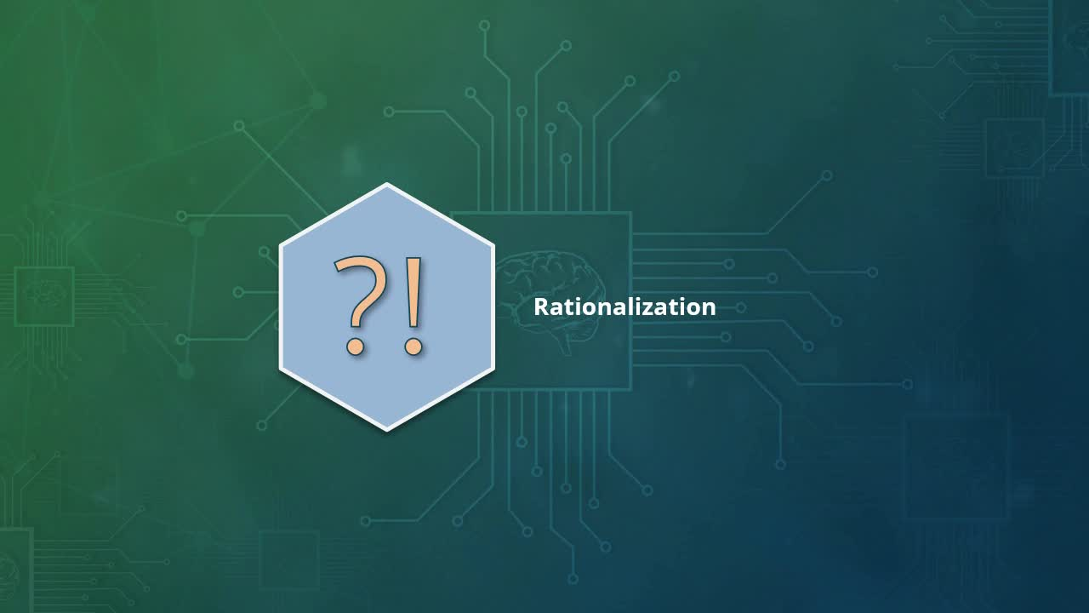
In this video, find out how to describe the meaning and application of rationalization.
- describe the meaning and application of rationalization
[Video description begins] Topic title: Rationalization. Your host for this session is Joaquin Marques. [Video description ends]
Rationalization is a very interesting AI interpretability method. Ideally, we would like the AI to be capable of telling us what it's going on through its mind as it makes decisions, just as a human would. Rationalization gets us closer to that dream. Imagine we ask a human art expert to look at da Vinci's original Mona Lisa painting and describe step by step what features he looks for and how he analyzes them? And verbally describe what he does and thinks about at every step. We capture all that information as data. Suppose we then encode all the data and tie those features in their comments to those embedded into a deep learning network trained to detect fake Mona Lisas.
Now, imagine we present our neural network with a Mona Lisa painting and ask it to describe step by step what it is looking for, what it sees, and what conclusions it derives, until it arrives at a conclusion. Is it a Mona Lisa or not? Every time certain nodes and paths, or conceptual areas in certain layers are activated. The activation triggers the art expert's verbal output originally associated with those very nodes, paths and conceptual areas captured by the original data encoding. Just like the original human art expert, it can rationalize its conclusions in terms a human can easily understand. That is what the rationalization method is all about.

10. Video: Feature Visualization (it_aiexpldj_01_enus_10)

In this video, you will learn how to describe the meaning and use of feature visualization.
- describe the meaning and application of feature visualization
[Video description begins] Topic title: Feature Visualization. Your host for this session is Joaquin Marques. [Video description ends]
Feature visualization is the last method in our list and one of the most interesting, for it uses not one, but two neural networks. One of them acts as our usual critic or adversary network, while the other acts as the painter of new fakes. It creates, generates new fakes. And it is known as the generative network. Their combination is known in the literature as a generative adversarial network, or GAN for short. The video shows our example of a generative adversarial network applied to our beloved Mona Lisas. Let's call the generative side the painter and the adversarial side the critic.
The painter learns to generate a perfect Mona Lisa from stroke and paint data obtained by scanning the original Mona Lisa with X-rays. We then introduce a source of random variation into the painter's code so that it starts generating different random variations of the original Mona Lisa within certain reasonable limits. No place for Picassos or Boteros here. All those Mona Lisa variations are fed to the critic to get it's verdict, real or fake?
Whenever the critic rejects a Mona Lisa variation as fake or accepts it as real, this information is fed back into the painter to retrain it to produce better and better fakes. For example, when the critic rejects Mona Lisa's curly eyelashes, the painter takes note of it and avoids using them again. When the critic accepts a smile, the painter tends to use smiles from that point on. The painter keeps track of each of these improvements. As the fake Mona Lisas get better, the critic rejects fewer of them. Finally, the painter reports step-by-step, in minute detail, how it eventually was able to convince the critic to accept its fake Mona Lisas as genuine. Now we have a true glimpse into the mind of the critic.

11. Video: Course Summary (it_aiexpldj_01_enus_11)
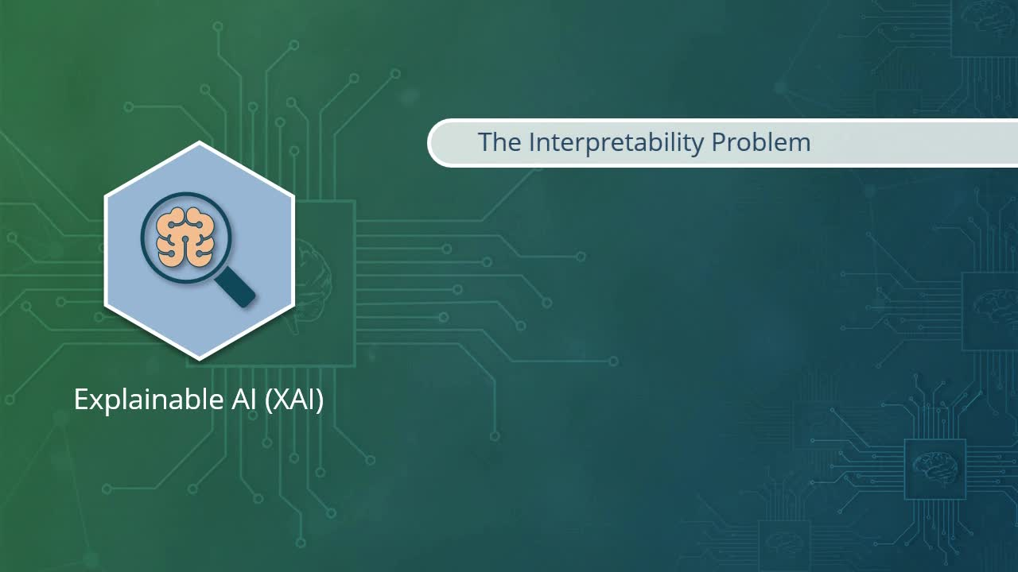
In this video, we will summarize the key concepts covered in this course.
- summarize the key concepts covered in this course
[Video description begins] Topic title: Course Summary [Video description ends]
We have reached the end of our journey into XAI or explainable AI. We started by getting an understanding of the interpretability problem as a central concept of explainable AI. We discussed the right to explanation and described several real world examples. We then described six different approaches to solving the interpretability problem, one by one, applying each of them to the task of recognizing the real Mona Lisa. The counterfactual method was introduced. And we pointed out its pros and cons, including the fact that it requires a lot of samples and testing time. We described the axiomatic method and noted that it takes fewer samples and less testing time than the counterfactual method.
Next, we investigated the intelligible models method and how it was best applied to numerical data and not image data. But we still managed to use it to recognize the real Mona Lisa from faked ones. We explained the difficult concept behind monotonicity and described how it differs from the other methods in that it looks for similarities and not differences. Which is ideal to solve certain types of problems, such as recognizing variations on a theme. We presented the rationalization method, helping us understand how we can get a neural network to do its own introspection into its inner workings. And finally, we looked at the feature visualization method by using a GAN, or generative adversarial network, to create perfect fakes to get a glimpse into the critic's mind.

